Project: ER Diagram

Group: Raul Cordero, Divina Gorospe, Purva Chandel

3/14/2017

ER Diagram:

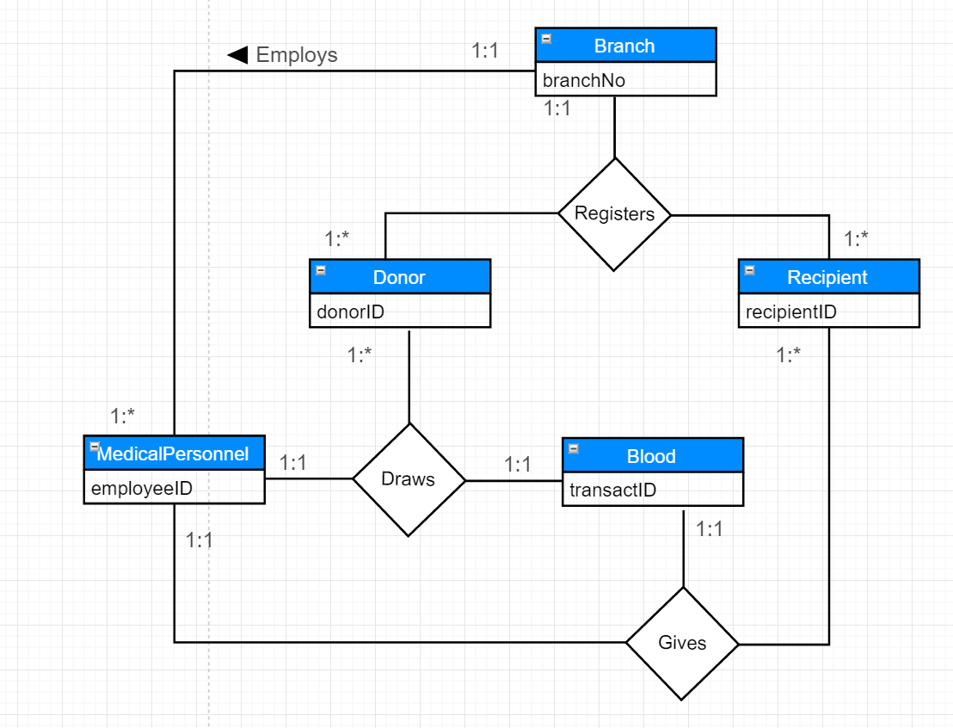

Entities:

Branch, Recipient, Donor, MedicalPersonnel

Relationships:

Registers, Employs, Requests, Gives, Donates, Draws

In our ER diagram, we have 4 major entities with 6 relationships. The first relationship begins with the entities Branch, Recipient, and Donor. Both the Recipient and Donor will need to be **Registered** at a Branch (1:1) before any transactions can occur. A Branch can have many Recipients or Donor (1:*). The second relationship is between the Branch and MedicalPersonnel entities. MedicalPersonnel can only be **Employed** at one branch (1:1). However, a Branch can employ many MedicalPersonnel (1:*). The third relationship is between the Donor and MedicalPersonnel entities. A Donor **Donates** blood many times (1:*) and can only have their blood **Drawn** (fourth relationship)by one MedicalPersonnel (1:1) per transaction. The MedicalPersonnel can draw blood from many Donors (1:*). The fifth relationship is between the Recipient and MedicalPersonnel entities. A Recipient can **Request** blood many times (1:*). The same as Donor, the Recipient can only have blood **Given** (sixth relationship)to them by one MedicalPersonnel (1:1) per transaction. The MedicalPersonnel can give blood to many Recipients (1:*).

The ER Diagram above depicts the main entities, their primary keys, and their relationships. The main entities are: Branch, Donor, Recipient, MedicalPersonnel, and Blood. Each entity has their primary keys depicted. Branch would have branchNo as the primary key.  Donor will have the donorID as the primary key. Recipient will have recipientID as the primary key. MedicalPersonnel will have employeeID as its primary key. Blood will have transactID as its primary key. The Donor and Recipient must register at a Branch before they can donate/request Blood. A MedicalPersonnel must be employed at the Branch.

The ER diagram depicts two degrees of relationship: three binary and two ternaries. The first binary relationship Registers is with two participating entity types between Branch and Donor. The second binary relationship Registers is with two participating entity types between Branch and Recipient. The third binary relationship Employs is with two participating entity types between Branch and MedicalPersonnel. The first ternary relationship Gives is with three participating entity types: MedicalPersonnel, Recipient, and Blood. The second ternary relationship Draws is with three participating entity types: MedicalPersonnel, Donor, Blood.

The relationships between these entities and their constraints are as follows:

1. A Branch employs one to many MedicalPersonnel (1:*). A MedicalPersonnel can only be employed at one Branch (1:1). Binary relationship
2. A Donor can only be registered at one Branch (1:1). A Branch can have many Donors (1:*). Binary relationship
3. A Recipient can only be registered at one Branch (1:1). A Branch can have many Recipients (1:*). Binary relationship
4. A MedicalPersonnel can draw many Blood from many Donors (1:*). A Donor can only have their blood drawn by one MedicalPersonnel (1:1). Ternary relationship
5. A MedicalPersonnel can give Blood to many Recipients (1:*). A Recipient can only receive Blood from one MedicalPersonnel (1:1). Ternary relationship

Contribution: We all contributed to this part of the project. We used draw.io on google drive to draw out the ER Diagram. When using google drive we were all able to add bits and pieces to the diagram and every time someone added something to the diagram it would automatically update on all of our screens. This way we were all able to contribute to the diagram. We also wrote down the paragraph using google docs, meaning we all had a say on what the final paragraphs would look like.